**Ajman University**

**College of Engineering**

**Department of Electrical Engineering**

  
**ELE314  
Microprocessors & Microcontrollers**

**Course Project Report**

**Students Names:**

* **Name: Marwa Dawood Alshouli ID: 201710906**
* **Name: Somaya Ahmad Samra ID: 201710614**

**Practical Section (Day/Time): Sunday, 12:30 PM**

**Practical Instructor: Engr. Yehia Ibrahim**

**Comments & Marks:**

**________________________________________________________________________________________________________________________________________________________________________________________________________________________________________________________________**

**Submission date: 6th of December**

**Project Description:**

Design and implement a system which is composed of: a conveyor belt and two Sensors.

• The 1st sensor is going to send a pulse to microcontroller whenever a box passed through it.

• The 2nd Sensor will measure the total weight of the boxes.

The system counts the boxes normally using TMR0, knowing that each box ≈ 1KG. Once the count reaches 9, the system should stop the motor for 5 seconds to allow the workers to take the 9 boxes. Then the system restarts the counting again.

The total weight should be within the expected range which is 8 to 10 KG. If the Total Weight is not within the expected range, then notify the workers by turning on a Red LED. Otherwise keep the Red Led Turned Off and Keep the Green LED Turned ON.

**Circuit Connection:**

**Required Components:**

* PIC16F887 Microcontroller
* RED/GREEN LEDs
* 2 Potentiometers
* LCD
* 4 Resistors
* 2 Push Buttons
* Motor

**Software Implementation:**

Case 1: weight is within the limit and number of boxes did not reach 9.



 Case 2: weight is over the limit.

 Case 3: weight is under the limit.

Case 4: Number of boxes reached 9 (motor stops for 5 secs and counter resets).



**Hardware Implementation:**

Case 1: weight is within the limit and number of boxes did not reach 9.

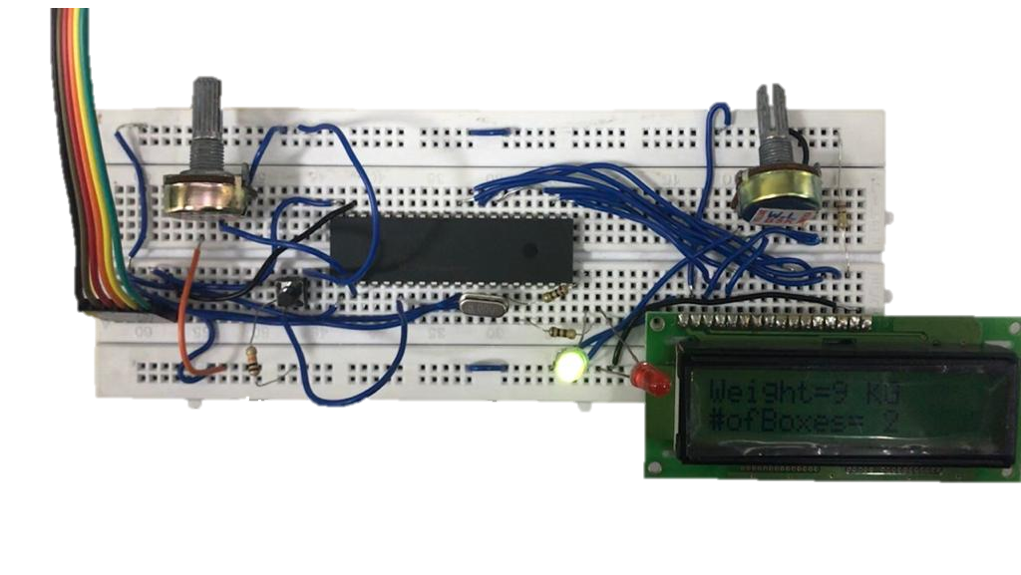

Case 2: weight is over the limit.

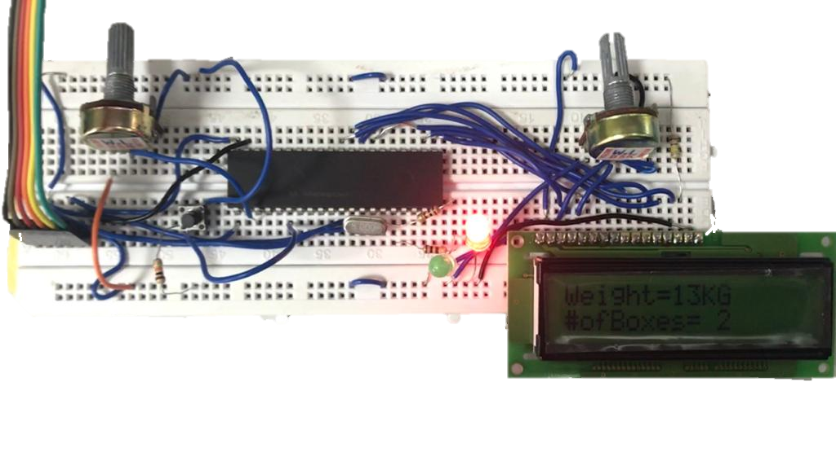

Case 3: weight is under the limit.

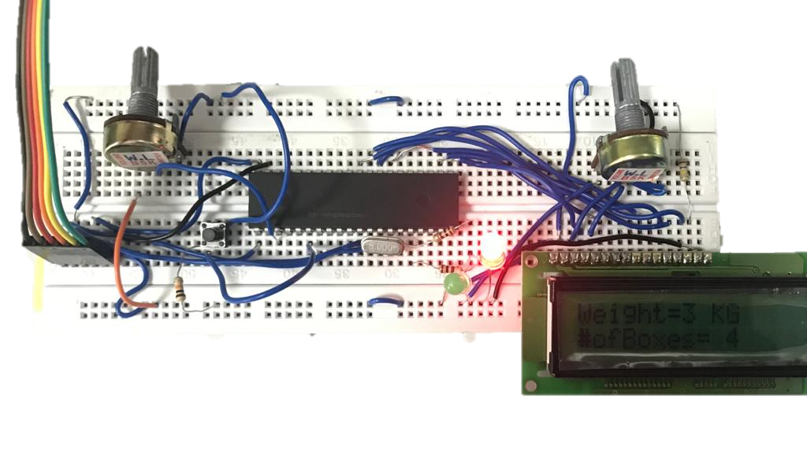

Case 4: Number of boxes reached 9 (motor stops for 5 secs and counter resets).

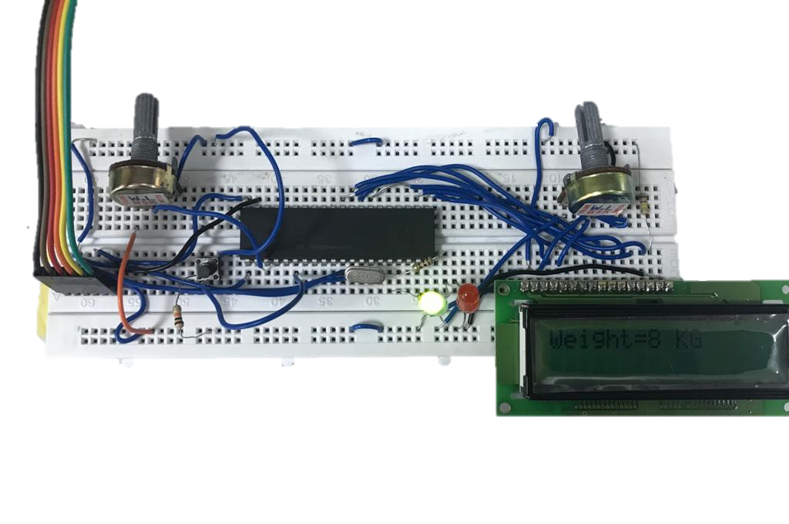

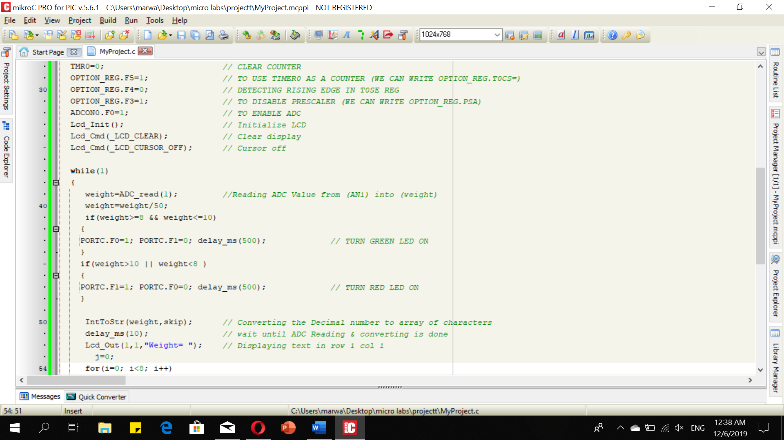**Code:**

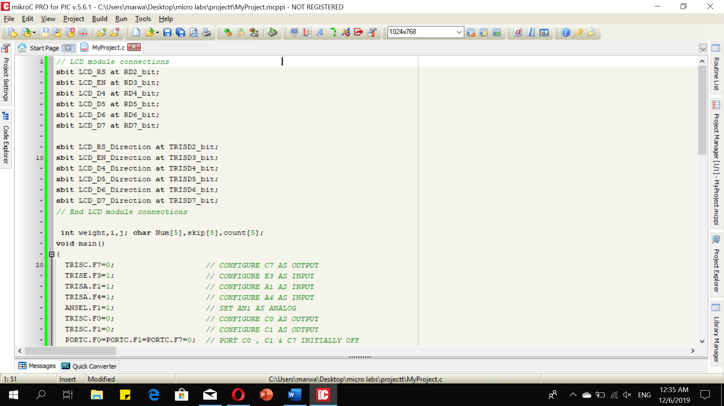

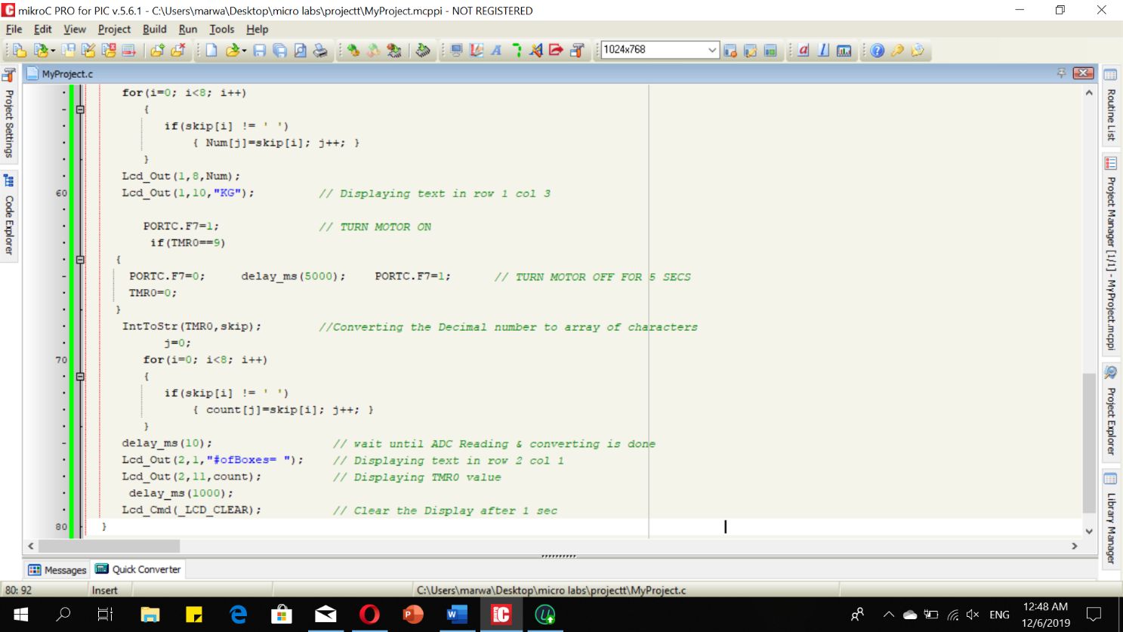

**Conclusion:**

For this project, a timer (TMR0) was used to count the boxes, when the total weight of boxes is between 8kg-10kg a green LED is turned on and when the total weight is out of limit a red LED is turned on.

When the number of boxes reaches 9; the motor stops for 5 seconds allowing the workers to unload the boxes then the counting restarts again.